**COMPREHENSIVE DIGITAL MARKETING OF WOW COSMETICS**

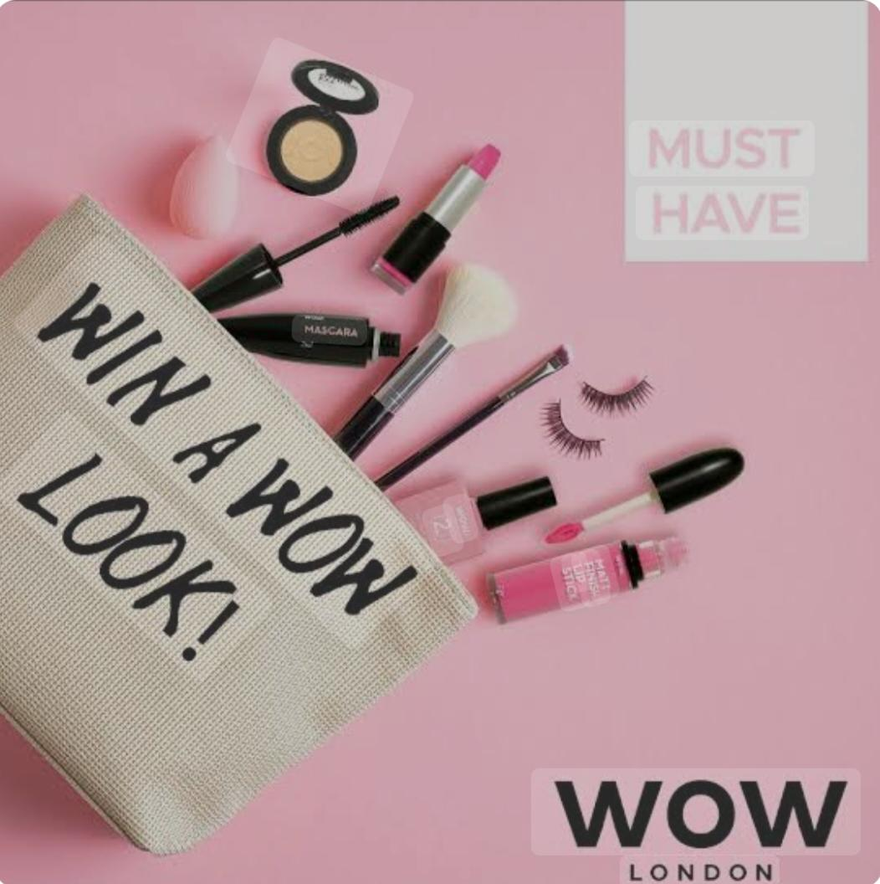

Wow cosmetics is a popular beauty and skincare brand that focuses on providing natural cruelty-free and vegan products.The company offers a wide range of products including face cleansers, moisturizers,haircare products,body scrubs, and serums.Many of WOW cosmetics products are formulated with ingredients like plant extracts, essential oils,and vitamis, which are meant to be gentle on the skin and suitable for various skin types.

The brand has gained attention for it's emphasis on clean beauty, free from harmful chemicals such as parabens, sulfates and artificial fragrance.Wow'd product lines often cater to those looking for effective, environment friendly alternatives in their skincare and hair care routines.

**Competitor Analysis**

It's essential to focus on other brands within the skin care and beauty space that emphasize natural, cruelty-free, and vegan products. Here's a breakdown of WOW cosmetics primary competitors.

**1.The Body Shop:**

The body shop is a well established global brand known for its commitment to ethical sourcing, cruelty-free products, and natural ingredients.

They offer a similar range of products, including skincare, body care, and hair care like wow cosmetics.

**2. Biotique:**

Biotique is an Ayurvedic-based skincare and personal care brand. It offers products with natural ingredients, focusing on wellness and holistic beauty.

Like Wow cosmetics, provides a broad range of skincare and hair care solutions, often highlighting natural herbs.

**3. Mamaearth**:

Mamaearth is an Indian brand that specializes in toxin-free and environmentally conscious skincare, hair care and personal care products.It shares a similar focus on naturalingredients.

**Buyer's/Audience persona**

* Demographics:Middle aged females who live in urban areas, primarily in metro cities. Most of them are working professionals.

* Psychographic:Most of the

Womens are interested in value

Sustainability n environmental consciousness.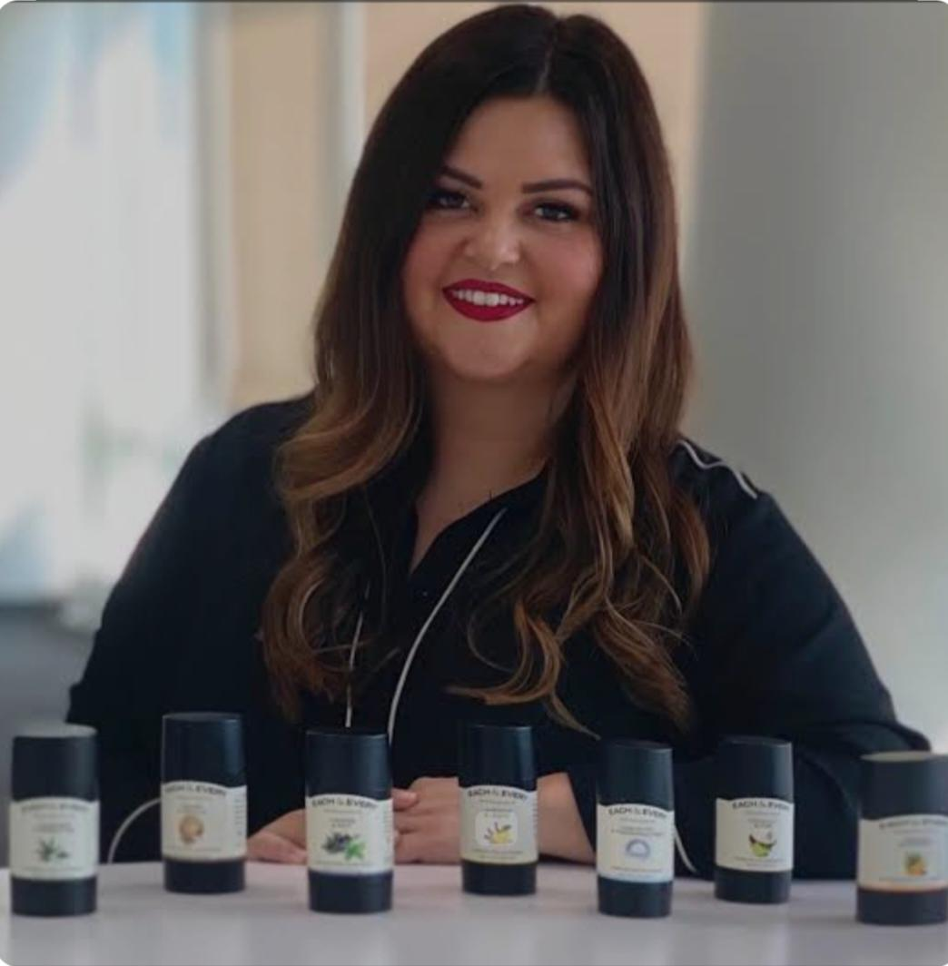

*Goals: Their goals r to maintain

healthy, glowing skin without using

Products that harm their health or the environment.

**SEO & Keyword research**

It identifies areas of improvement, helps improve site structure, and increases visibility and ranking on search engine like Google. For Wow cosmetics, conducting an SEO audit can help uncover potential issues and opportunities for optimization.

Based on the nature of WOW cosmetics, here are some primary and secondary kerwords categories and suggestions.

1. Natural skincare

2.Chemical-free skincare

3.Cruelty-free cosmetic

4.Paraben-free cosmetics

5. Vegan skincare products

6. Eco-friendly products.

7. Sulfate free shampoo 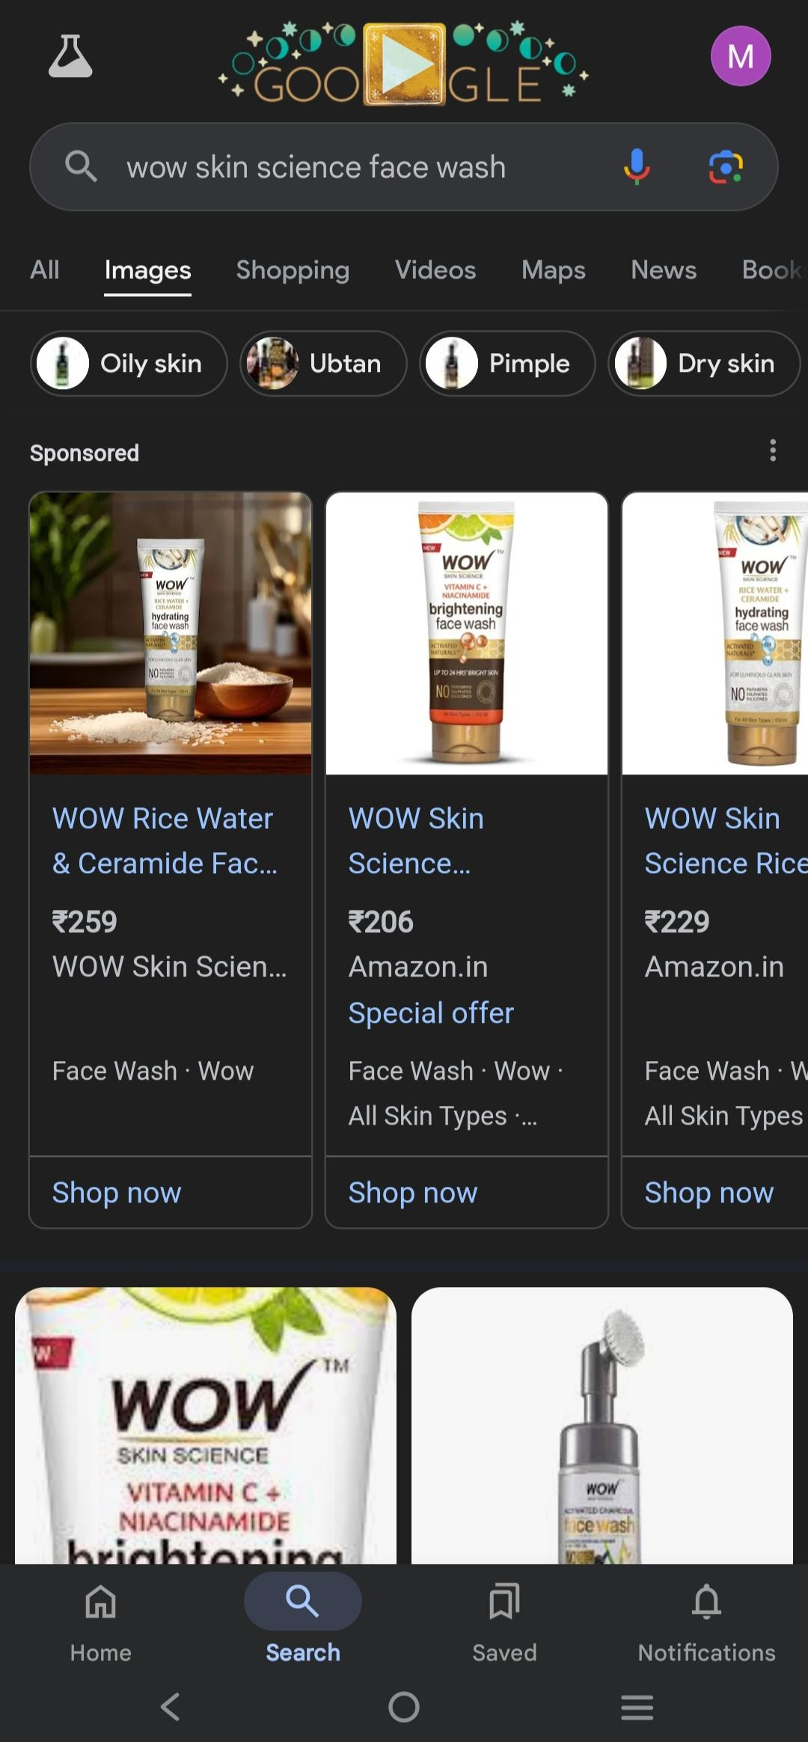

**Content ideas & Marketing strategy**

**Content ideas**

**1. Ingredient spotlight Series:**

Social media posts or Blog Articles create a content that focuses on the key natural ingredients used in Wow cosmetics, explaining their benefits and how they contribute to healthy skin.

**2.Customer testimonials & Before-After**

**stories**:

User-Generated Content encourage customer to share their skin transformation stories. This can be shared across social media, with hashtags like

#WowSkin Transformation

Vedio reviews reach out to influence or every day customers to create Vedio content showcasing their real time results.

**3. Sustainability focus:**

Eco-friendly packaging campaigns Highlights the brand's commitment to sustainable packaging through visual content.Share beauty tips share educational

content on how your products are not only effective but also environmentlly responsible.

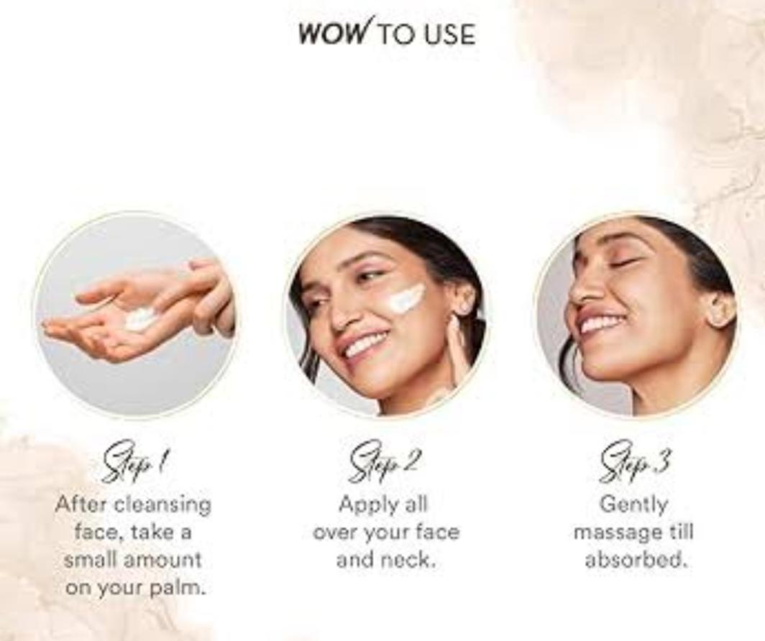

**4. Tutorials & How-Tos:**

Skincare routines post step-by-step guides on how to incorporate Wow products into daily skincare routines for different skin types.

* Live skincare Demos Hosts live sessions on instagram or Facebook to show how to use products correctly.

**5.Seasonal Promotions & Bundles:**

Limited-Edition Holidays Sets create bundles that align with holidays or events, like Valentine's day or Mother's day, and market them as gift sets.

Educate consumers about changing skincare routines based on the seasons.

**6.Collaboration with influencer:**

Work with beauty influencers or skincare experts who align with your brand values. Have them create content around Wow Cosmetics, whether through sponsored posts, unboxing or reviews.

**Marketing Ideas**

**1.social media campaign:**

Hashtags create a signature hashtags like #WowYourSkin to build brand recognition and encourage customers to engage with your posts.

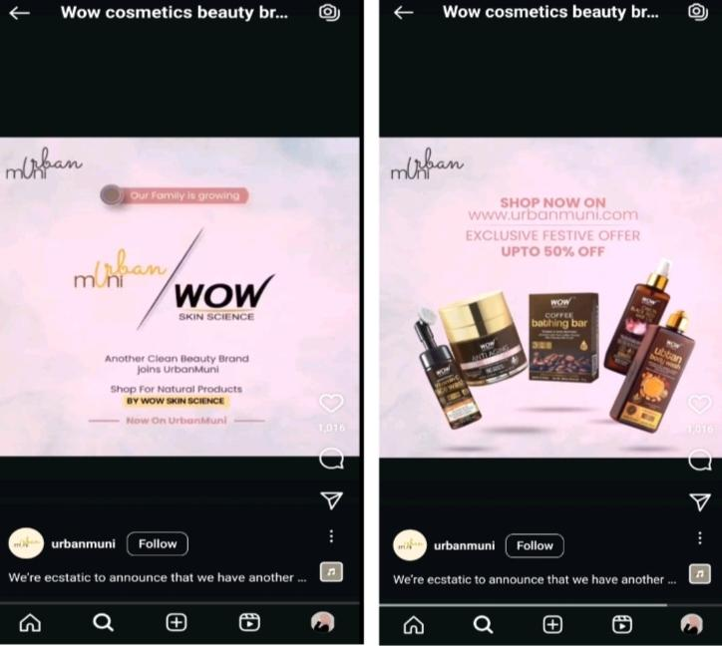

Instagram Stories/Reels engage with short-form videos content by creating fun, educational, or aspirational skincare-related clips.Show quick results, products uses, or skincare routines.

**2.Email Marketing:**

Exclusive Discounts for Subscribers offers an exclusive 10-20% off for first time customers when they sign up for your newsletters.

Weekly tips & Promotions regular send out skincare tips, users stories, or new product launches to keep customers engaged.

Personalized Recommendations based on past purchases or interests, suggest new products to help users meet their skin care goals.

**3.Google Ads & Facebook**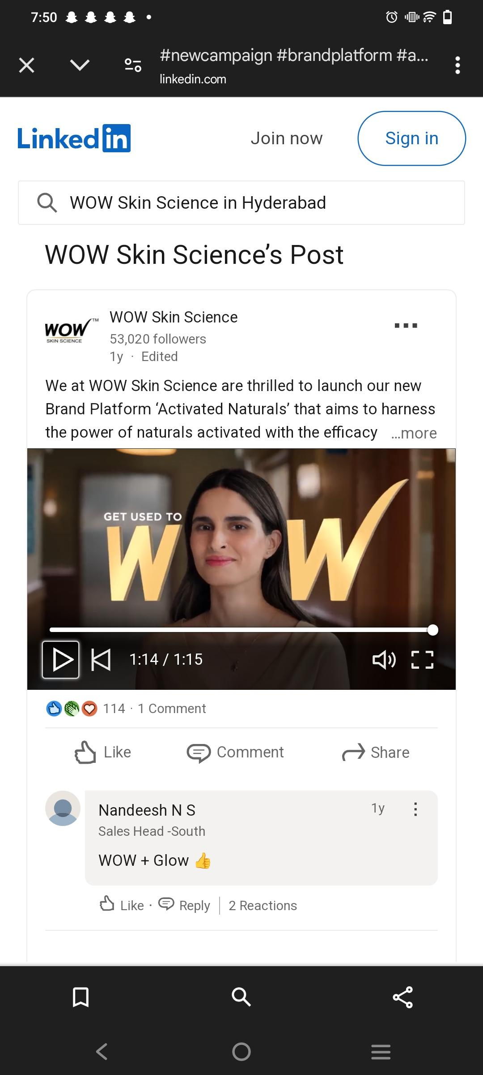

**Run targeted Ads features**

Your most Popular product.

Focus on Keyword Optimization

Like 'natural Skincare' or 'Senstitive skin

Solutions ' to attract the righ audience.

Collaborate with health & beauty bloggers,Pop-up Events or Virtual webinars and Give aways n Contests.

**Content Creation and Curation**

**1.Ingredient spotlight post:**

Post type may be Image or carousal

Use high quality images of the ingredient and product shots of items containing it.

**2.Before & After Transformation Posts:**

Post type may be Carousal or vedio

Use a carousel of before n after images, showing the transformation.Ensure the lighting and framing are consistent for clarity.

**3.Skincare Tips Posts:**

Post type should be single image or a carousel.

Content ideas be like

✨Skincare tip of the week✨

Show the products being used in a fresh and relaxing bathroom setting with soft lighting for a clean, minimalist aesthetic.

Some of the other type of posts are

**4.Customer testimonial post**

**5.Eco-friendly Campaign Post**

🌎 Beauty that loves the Earth 🌎

**6.Product Launch or Restock Post**

🚨NEW ARRIVAL 🚨

**Thanking**

I would like to thank for the opportunity to contribute to this project.The journey of the crafting content, designing and strategies and curation ideas for wow cosmetics has been truly rewarding. I am excited to see how the strategies and insights shared will help elevate the brand.

Lastly, thank you for this opportunity and look forward to supporting future initiatives and continued success for WOW COSMETICS.

Presentd by

Syeda.Muskaan

[syedamuskaan574@gmail.com](mailto:syedamuskaan574@gmail.com)

Hall no: 22350014017

Vasavi Mahila Kalasala.